Contents

Part A 1

1. 1

Part B 2

1. 2

2. 3

Part C 4

Part D 5

# Part A

## 1.

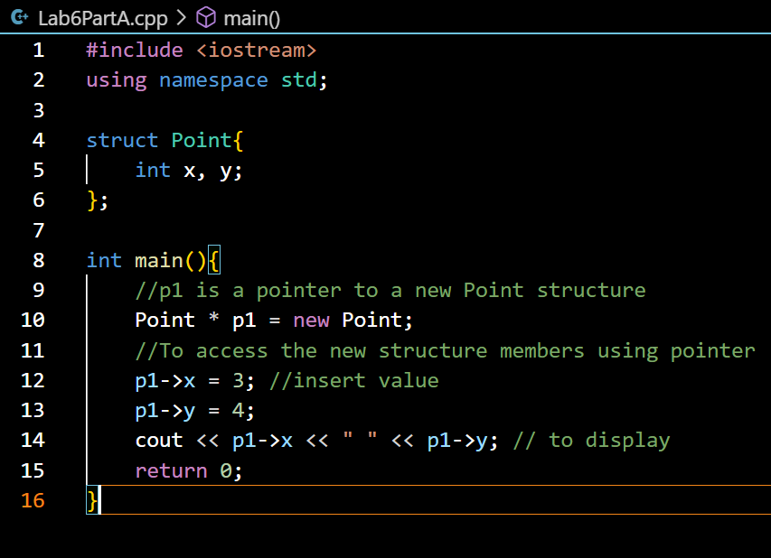



# Part B

## 1.

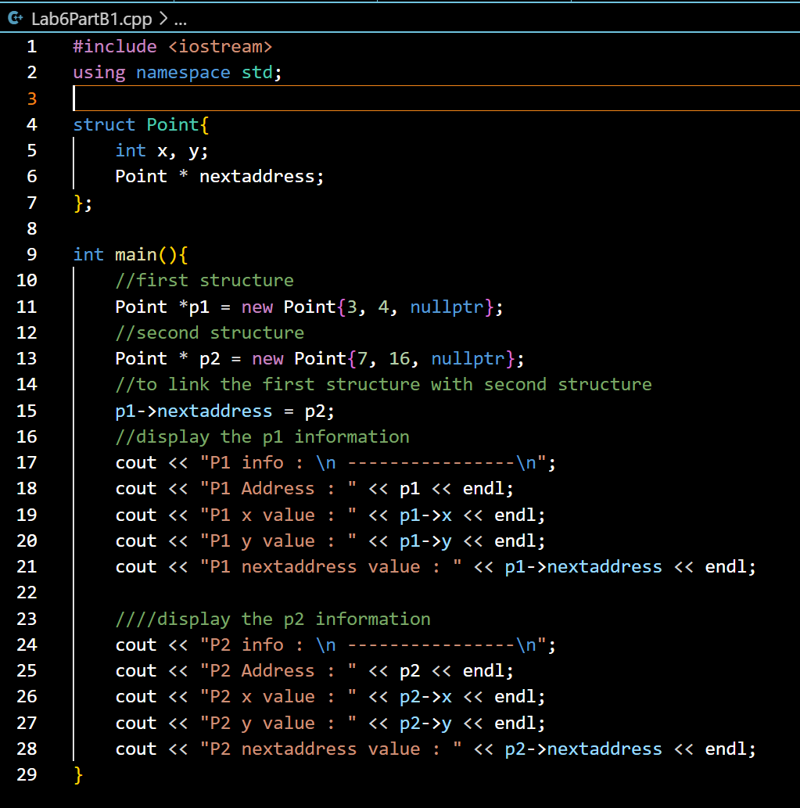

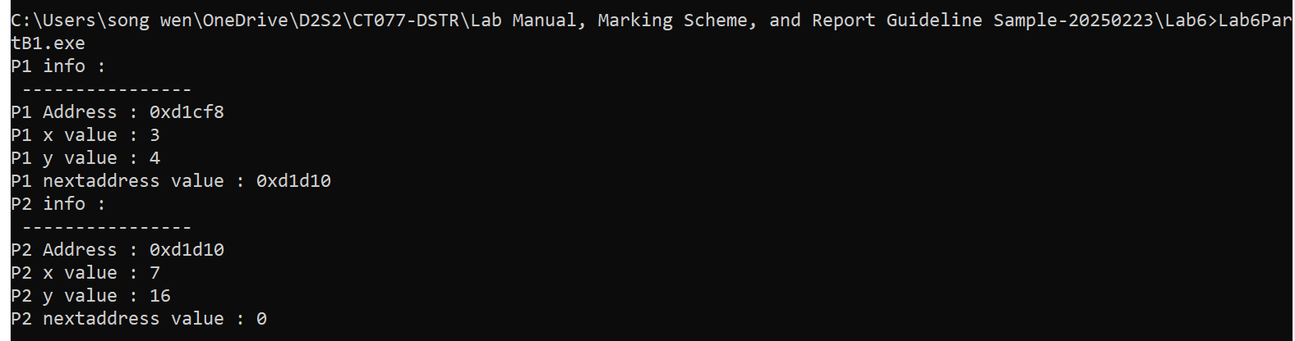

## 2.

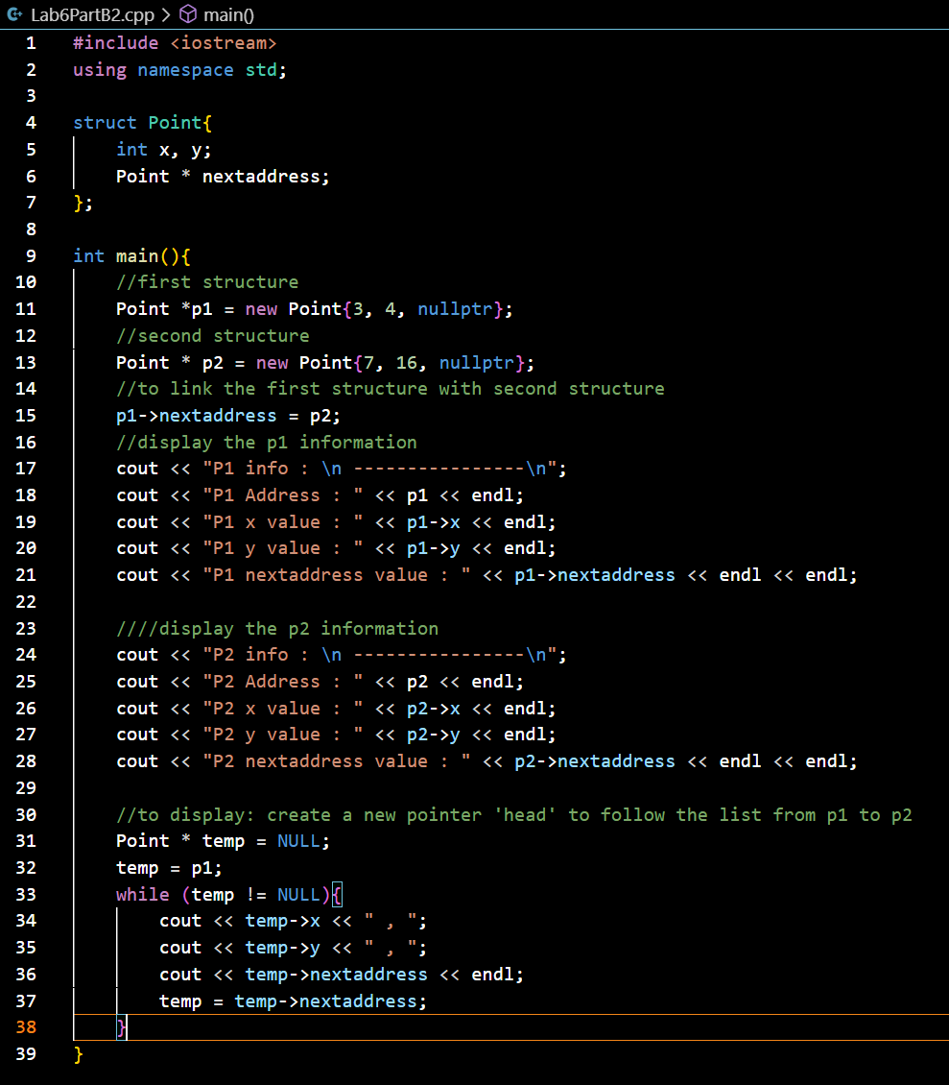

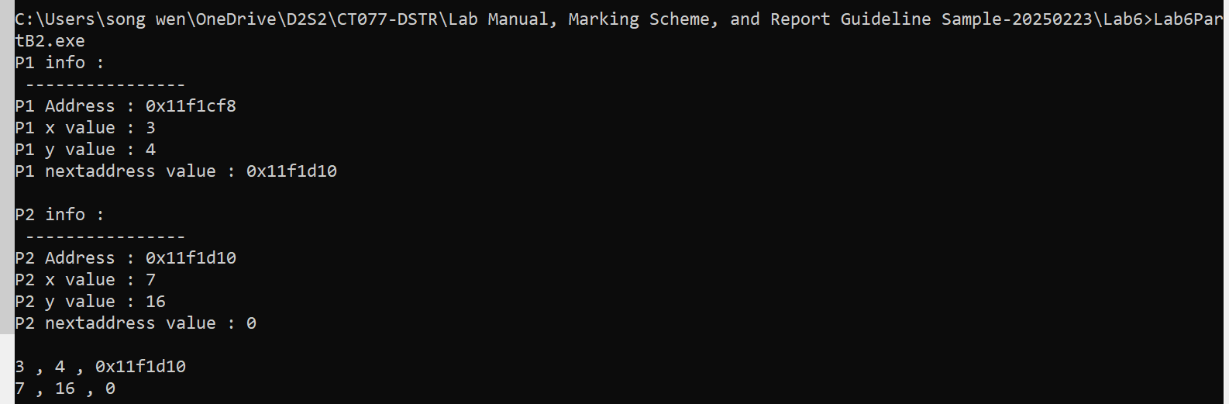

# Part C

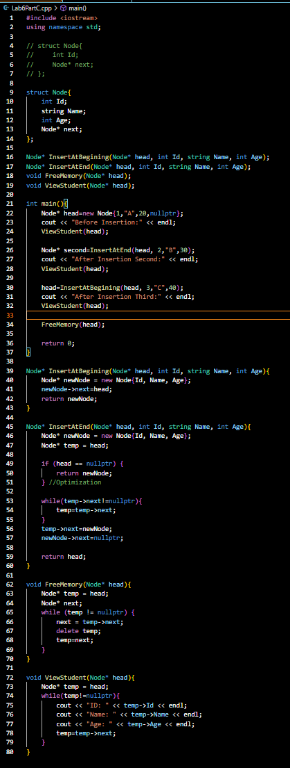

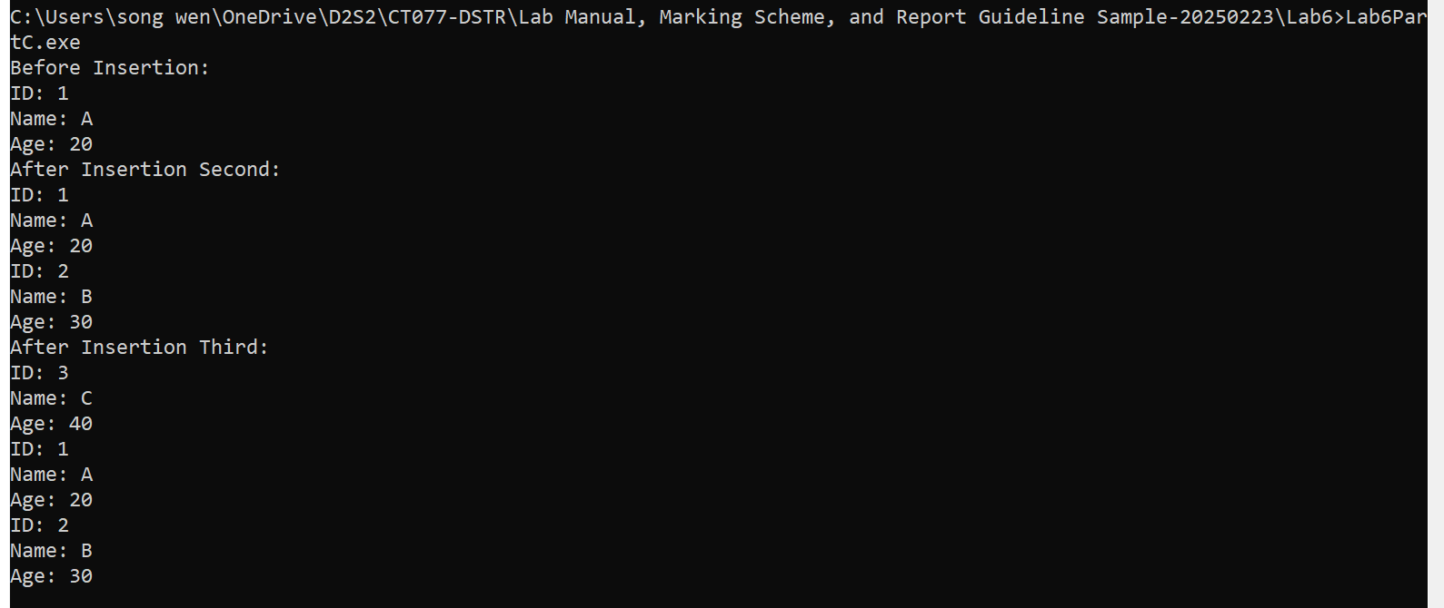

# Part D

